**Assignments**

**OOPS**

1. **Create Java Class from Class Diagram**

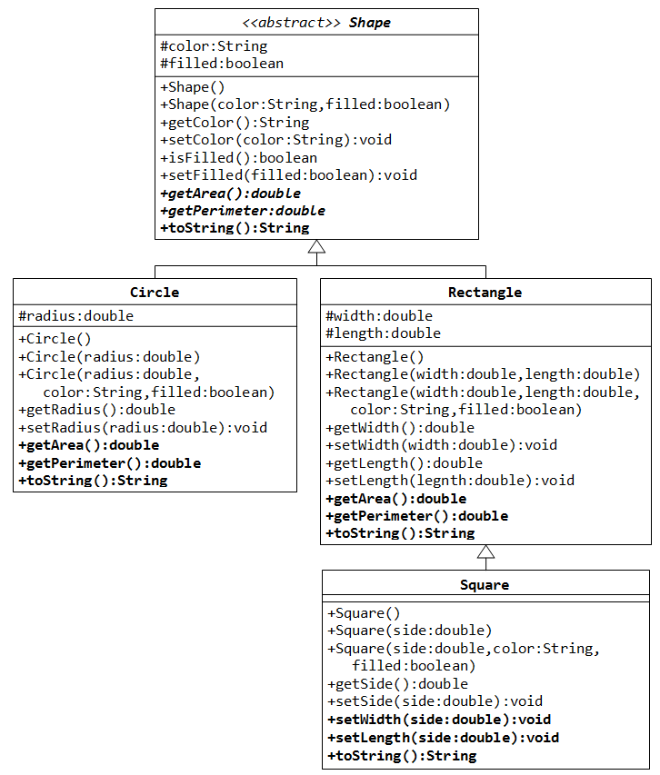

1. **Java Inheritance**

Using inheritance, one class can acquire the properties of others. Consider the following Animal class:

class Animal{

void walk(){

System.out.println("I am walking");

}

}

This class has only one method, walk. Next, we want to create a Bird class that also has a fly method. We do this using extends keyword:

class Bird extends Animal {

void fly() {

System.out.println("I am flying");

}

}

Finally, we can create a Bird object that can both fly and walk.

public class Solution{

public static void main(String[] args){

Bird bird = new Bird();

bird.walk();

bird.fly();

}

}

The above code will print:

I am walking

I am flying

This means that a Bird object has all the properties that an Animal object has, as well as some additional unique properties.

Now,You must add a sing method to the Bird class, then modify the main method accordingly so that the code prints the following lines:

I am walking

I am flying

I am singing

1. **Convert to Java Class**

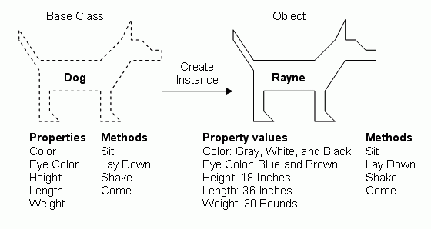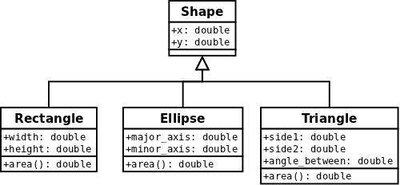

1. ***Is the code compiles? If yes then what will be the output?***

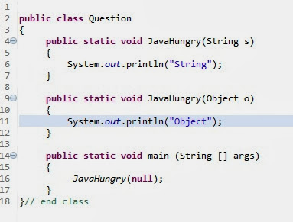

1. ***Is the  code compiles ? If  yes then what will be the output ?***

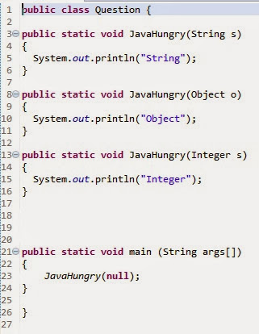

1. ***Is the  code compiles ? If  yes then what will be the output ?***

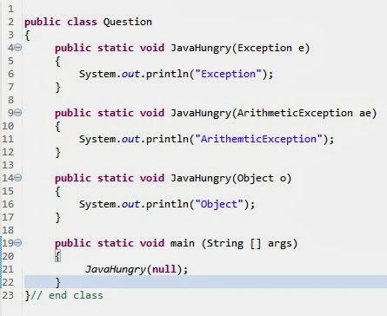

1. ***Is the  code compiles ? If  yes then what will be the output ?***



1. ***Is the  code compiles ? If  yes then what will be the output ?***

